

**Dharmsinh Desai University**

**Academic Year: 2022-23**

**Department: Institute of Management &**

**Information Science**

**Subject**

**Community Website (Freshhminds)**

|  |  |
| --- | --- |
| **Full Name: Sutariya Savankumar S.**  **Roll No: MA061**  **ID No: 22MAPOG030**  **Student Sign.** | **Submitted to Prof.**  **MVS**  **Professor Sign.** |

Contents

Contents 1

What is FreshhMinds 2

Structure of Website 2

HTML Pages 3

Index.html 3

events.html 4

explore.html 7

about.html 7

ghw.html (Event) 9

summerbootcamp.html (Event) 11

100daysofcode.html (Explore) 11

showcase.html (Explore) 12

opensource.html (Explore) 14

CSS files 16

style.css 16

Screenshots 22

Index.html 22

events.html 23

explore.html 24

about.html 25

ghw.html (Event) 26

100daysofcode.html 27

showcase.html 28

opensource.html 29

# What is FreshhMinds

FreshhMinds is a platform for students to share their ideas and projects with the world. It is a platform for students to showcase their talent and get recognized for their work. It is a platform for students to learn and grow. It is a platform for students to get inspired and inspire others.

# Structure of Website

|  |  |  |
| --- | --- | --- |
| **Components**   1. Navigation bar    * Logo    * Navigation links    * Join link (freshhminds.github.io) 2. Footer    * Socials    * Partners    * Copyright ©   **Pages**   * 1. Home page:   + Information About Community   + Recent Activity   + Footer  1. Events**:**    * Events list:      1. Banner      2. Title      3. Short Description      4. Link    * Event pages      1. Event Banner      2. Detailed Description      3. Date/time, Venue, etc. Information | 1. Explore:    * #100DaysOfCode      1. Banner      2. About      3. Twitter timeline    * Show Case      1. Learn In Public         1. Idea   Blogs   * + Open Source     1. About     2. Projects        1. Image with Github link        2. Name  1. About:    * Group Picture    * About Community    * Team members  |  | | --- | | **Technologies**   * HTML5 * CSS3 | |

# HTML Pages

## Index.html

<!DOCTYPE html>

<html lang="en">

<head>

    <title>FreshhMinds</title>

    <link rel="stylesheet" href="style.css">

</head>

<body>

    <header class="navbar">

        <div class="logo">

            <img src="images/Freshhminds_Dark.png" alt="FreshhMinds">

        </div>

        <div class="nav">

            <a href="index.html" class="nav-item">Home</a>

            <a href="events.html" class="nav-item">Events</a>

            <a href="explore.html" class="nav-item">Explore</a>

            <a href="about.html" class="nav-item">About</a>

            <a href="https://freshhminds.github.io/" class="nav-item">Join us</a>

        </div>

    </header>

    <div class="container">

        <section class="Home">

            <img src="images/FreshMinds.gif" alt="FreshhMinds">

            <h1>FreshhMinds</h1>

            <center><p>This community is run solely by students, for students, to encourage development, open-source, and help the community unlock their full potential, one step at a time.</p></center>

        </section>

    </div>

    <div class="container">

        <!-- About Us -->

        <div class="news_sec">

            <h1>Recent Activity</h1>

            <div class="news">

                <img src="images/summerbootcamp.png" alt="News1">

                <div class="news_content">

                    <h2>Summer Bootcamp</h2>

                    <p>Summer bootcamp is a month-long event for beginners to get familiar and get an exposure to different tech stacks.</p>

                    <a href="events/summerbootcamp.html" target="_blank">Learn More</a>

                </div>

            </div>

            <div class="news">

                <div class="news_content">

                    <h2>Global Hack Weeks by MLH</h2>

                    <p>Global Hack Weeks by MLH are your opportunity to spend a week learning, building, and growing with the community. Each Global Hack Week features workshops, technical live streams, mini events, and more to help you grow as a technologist.</p>

                    <a href="events/ghw.html" target="_blank">Learn More</a>

                </div>

                <img src="images/ghw-banner.png" alt="News1">

            </div>

            <br>

            <center><a href="events.html" class="btn">Load more</a></center>

        </div>

    </div>

    <footer class="container">

        <h2>Follow Us</h2>

        <a href="https://github.com/freshhminds" target="_blank">Github</a>

        <a href="https://www.linkedin.com/company/freshhminds/" target="_blank">LinkedIn</a>

        <a href="https://twitter.com/freshhminds" target="_blank">Twitter</a>

        <h2>Our Partners</h2>

        <a href="https://www.mlh.io/" target="_blank">Major League Hacking</a>

        <a href="https://www.hackerearth.com/" target="_blank">HackerEarth</a>

        <a href="https://www.hackerrank.com/" target="_blank">HackerRank</a>

        <a href="https://www.hackerearth.com/" target="_blank">HackerEarth</a>

        <div class="footer_bottom">

            <p>© 2021 FreshhMinds. All rights reserved.</p>

        </div>

    </footer>

</body>

</html>

## events.html

<!DOCTYPE html>

<html lang="en">

<head>

    <meta charset="UTF-8">

    <meta http-equiv="X-UA-Compatible" content="IE=edge">

    <meta name="viewport" content="width=device-width, initial-scale=1.0">

    <title>FreshhMinds</title>

    <link rel="stylesheet" href="style.css">

</head>

<body>

    <header class="navbar">

        <div class="logo">

            <img src="images/Freshhminds_Dark.png" alt="FreshhMinds">

        </div>

        <div class="nav">

            <a href="index.html" class="nav-item">Home</a>

            <a href="events.html" class="nav-item">Events</a>

            <a href="explore.html" class="nav-item">Explore</a>

            <a href="about.html" class="nav-item">About</a>

            <a href="https://freshhminds.github.io/" class="nav-item">Join us</a>

        </div>

    </header>

    <div class="container">

        <!-- About Us -->

        <div class="news_sec">

            <h1>Events</h1>

            <div class="news">

                <img src="images/summerbootcamp.png" alt="News1">

                <div class="news_content">

                    <h2>Summer Bootcamp</h2>

                    <p>Summer bootcamp is a month-long event for beginners to get familiar and get an exposure to different tech stacks.</p>

                    <a href="events/summerbootcamp.html" target="_blank">Learn More</a>

                </div>

            </div>

            <div class="news">

                <div class="news_content">

                    <h2>Global Hack Weeks by MLH</h2>

                    <p>Global Hack Weeks by MLH are your opportunity to spend a week learning, building, and growing with the community. Each Global Hack Week features workshops, technical live streams, mini events, and more to help you grow as a technologist.</p>

                    <a href="events/ghw.html" target="_blank">Learn More</a>

                </div>

                <img src="images/ghw-banner.png" alt="News1">

            </div>

            <div class="news">

                <img src="images/summerbootcamp.png" alt="News1">

                <div class="news_content">

                    <h2>Summer Bootcamp</h2>

                    <p>Summer bootcamp is a month-long event for beginners to get familiar and get an exposure to different tech stacks.</p>

                    <a href="events/summerbootcamp.html" target="_blank">Learn More</a>

                </div>

            </div>

            <div class="news">

                <div class="news_content">

                    <h2>Global Hack Weeks by MLH</h2>

                    <p>Global Hack Weeks by MLH are your opportunity to spend a week learning, building, and growing with the community. Each Global Hack Week features workshops, technical live streams, mini events, and more to help you grow as a technologist.</p>

                    <a href="events/ghw.html" target="_blank">Learn More</a>

                </div>

                <img src="images/ghw-banner.png" alt="News1">

            </div>

        </div>

    </div>

    <footer class="container">

        <h2>Follow Us</h2>

        <a href="https://github.com/freshhminds" target="_blank">Github</a>

        <a href="https://www.linkedin.com/company/freshhminds/" target="_blank">LinkedIn</a>

        <a href="https://twitter.com/freshhminds" target="_blank">Twitter</a>

        <h2>Our Partners</h2>

        <a href="https://www.mlh.io/" target="_blank">Major League Hacking</a>

        <a href="https://www.hackerearth.com/" target="_blank">HackerEarth</a>

        <a href="https://www.hackerrank.com/" target="_blank">HackerRank</a>

        <a href="https://www.hackerearth.com/" target="_blank">HackerEarth</a>

        <div class="footer_bottom">

            <p>© 2021 FreshhMinds. All rights reserved.</p>

        </div>

    </footer>

</body>

</html>

## explore.html

much the same layout as events.html

## about.html

<!DOCTYPE html>

<html lang="en">

<head>

    <meta charset="UTF-8">

    <meta http-equiv="X-UA-Compatible" content="IE=edge">

    <meta name="viewport" content="width=device-width, initial-scale=1.0">

    <title>FreshhMinds</title>

    <link rel="stylesheet" href="style.css">

</head>

<body>

    <header class="navbar">

        <div class="logo">

            <img src="images/Freshhminds_Dark.png" alt="FreshhMinds">

        </div>

        <div class="nav">

            <a href="index.html" class="nav-item">Home</a>

            <a href="events.html" class="nav-item">Events</a>

            <a href="explore.html" class="nav-item">Explore</a>

            <a href="about.html" class="nav-item">About</a>

            <a href="https://freshhminds.github.io/" class="nav-item">Join us</a>

        </div>

    </header>

    <div class="container">

        <!-- About Us -->

        <div class="about_us">

            <h1>About Us</h1>

            <img src="images/htfmeetup.png" alt="Freshhminds">

            <center><p><span>FreshhMinds</span> is a student-run community focusing on open-source, project-based learning. It aims to help folks to get opportunities by encouraging them to learn, build and share in public.

                We encourage folks to get started with open-source and conduct multiple events around the same. We are a community of more than 400+ members and growing every day.</p></center>

        </div>

        <hr>

        <div class="people">

            <div class="person">

                <img src="images/p2.jpg" alt="Parth">

                <b><p>Parth</p></b>

                <a href="https://twitter.com/BelaniParth">Twitter</a>

            </div>

            <div class="person">

                <img src="images/p3.jpg" alt="Kunal">

                <b><p>Kunal</p></b>

                <a href="https://twitter.com/kunalstwt">Twitter</a>

            </div>

            <div class="person">

                <img src="images/p1.png" alt="Savan">

                <b><p>Savan</p></b>

                <a href="https://twitter.com/savansutariya">Twitter</a>

            </div>

            <div class="person">

                <img src="images/p5.jpg" alt="Saumya">

                <b><p>Saumya</p></b>

                <a href="https://twitter.com/saumya1singh">Twitter</a>

            </div>

            <div class="person">

                <img src="images/p4.jpg" alt="Ishan">

                <b><p>Ishan</p></b>

                <a href="https://twitter.com/Ishansharma7390">Twitter</a>

            </div>

            <div class="person">

                <img src="images/p6.jpg" alt="Anuj">

                <b><p>Anuj</p></b>

                <a href="https://twitter.com/anujbhaiya716">Twitter</a>

            </div>

            <div class="person">

                <img src="images/p7.jpg" alt="Ayush">

                <b><p>Ayush</p></b>

                <a href="https://twitter.com/AySh2218">Twitter</a>

            </div>

        </div>

    </div>

    <footer class="container">

        <h2>Follow Us</h2>

        <a href="https://github.com/freshhminds" target="_black">Github</a>

        <a href="https://www.linkedin.com/company/freshhminds/" target="_blank">LinkedIn</a>

        <a href="https://twitter.com/freshhminds" target="_blank">Twitter</a>

        <h2>Our Partners</h2>

        <a href="https://www.mlh.io/" target="_blank">Major League Hacking</a>

        <a href="https://www.hackerearth.com/" target="_blank">HackerEarth</a>

        <a href="https://www.hackerrank.com/" target="_blank">HackerRank</a>

        <a href="https://www.hackerearth.com/" target="_blank">HackerEarth</a>

        <div class="footer_bottom">

            <p>© 2021 FreshhMinds. All rights reserved.</p>

        </div>

    </footer>

</body>

</html>

## ghw.html (Event)

<!DOCTYPE html>

<html lang="en">

<head>

    <meta charset="UTF-8">

    <meta http-equiv="X-UA-Compatible" content="IE=edge">

    <meta name="viewport" content="width=device-width, initial-scale=1.0">

    <title>FreshhMinds</title>

    <link rel="stylesheet" href="../style.css">

</head>

<body>

    <a id="mlh-trust-badge" style="display:block;max-width:100px;min-width:60px;position:fixed;right:20px;top:0;width:10%;z-index:10000" href="https://mlh.io/apac?utm_source=apac-hackathon&utm_medium=TrustBadge&utm_campaign=2023-season&utm_content=gray" target="_blank"><img src="https://s3.amazonaws.com/logged-assets/trust-badge/2023/mlh-trust-badge-2023-gray.svg" alt="Major League Hacking 2023 Hackathon Season" style="width:100%"></a>

    <header class="navbar">

        <div class="logo">

            <img src="../images/Freshhminds_Dark.png" alt="FreshhMinds">

        </div>

        <div class="nav">

            <a href="../index.html" class="nav-item">Home</a>

            <a href="../events.html" class="nav-item">Events</a>

            <a href="../explore.html" class="nav-item">Explore</a>

            <a href="../about.html" class="nav-item">About</a>

            <a href="../https://freshhminds.github.io/" class="nav-item">Join us</a>

        </div>

    </header>

    <div class="container">

        <!-- About Us -->

        <div class="about_us">

            <h1>Global Hack Weeks by MLH</h1>

            <img src="../images/ghw-banner.png" alt="Freshhminds">

            <center><p>Global Hack Weeks by MLH are your opportunity to spend a week learning, building, and growing with the community. Each Global Hack Week features workshops, technical live streams, mini events, and more to help you grow as a technologist.</p>

        </div>

        <hr>

        <!-- Event summery -->

        <div class="event_summery">

            <h2>Event Summery</h2>

            <center><p>In this event we encouraged all of our community members to participate in GHW INIT and GHW September, and we saw a lot of results. We were one of the top guilds in these two events. Almost everyday, a lot of people in our community ended up in the top 5% of the hackers in these events, and every passing day, more people took part in the event to join the fun!</p></center>

        </div>

        <hr>

        <!-- Event Details -->

        <div class="event_details">

            <center>

                <h1>Venue</h1>

                <p>Discord</p>

                <h1>Time</h1>

                <p>Saturday at 4:00 PM IST</p>

                <h1>Speaker</h1>

                <p>Elon Musk</p>

            </center>

        </div>

    </div>

    <footer class="container">

        <h2>Follow Us</h2>

        <a href="https://github.com/freshhminds" target="_blank">Github</a>

        <a href="https://www.linkedin.com/company/freshhminds/" target="_blank">LinkedIn</a>

        <a href="https://twitter.com/freshhminds" target="_blank">Twitter</a>

        <h2>Our Partners</h2>

        <a href="https://www.mlh.io/" target="_blank">Major League Hacking</a>

        <a href="https://www.hackerearth.com/" target="_blank">HackerEarth</a>

        <a href="https://www.hackerrank.com/" target="_blank">HackerRank</a>

        <a href="https://www.hackerearth.com/" target="_blank">HackerEarth</a>

        <div class="footer_bottom">

            <p>© 2021 FreshhMinds. All rights reserved.</p>

        </div>

    </footer>

</body>

</html>

## summerbootcamp.html (Event)

much the same layout as ghw.html

## 100daysofcode.html (Explore)

<!DOCTYPE html>

<html lang="en">

<head>

    <meta charset="UTF-8">

    <meta http-equiv="X-UA-Compatible" content="IE=edge">

    <meta name="viewport" content="width=device-width, initial-scale=1.0">

    <title>FreshhMinds</title>

    <link rel="stylesheet" href="../style.css">

</head>

<body>

    <header class="navbar">

        <div class="logo">

            <img src="../images/Freshhminds_Dark.png" alt="FreshhMinds">

        </div>

        <div class="nav">

            <a href="../index.html" class="nav-item">Home</a>

            <a href="../events.html" class="nav-item">Events</a>

            <a href="../explore.html" class="nav-item">Explore</a>

            <a href="../about.html" class="nav-item">About</a>

            <a href="../https://freshhminds.github.io/" class="nav-item">Join us</a>

        </div>

    </header>

    <div class="container">

        <!-- About Us -->

        <div class="about_us">

            <h1>#100daysOfCode Challenge</h1>

            <img src="../images/100daysofcode.png" alt="Freshhminds">

            <center><p>The 100 Days of Code challenge is a self-directed commitment by developers to build strong and consistent coding habits. The challenge uses social accountability, transparency, and deep reflection to form healthy developer habits.</p>

        </div>

        <hr>

        <!-- Tweets -->

        <div class="tweets">

            <center><h1 style="color: #fff">Twitter Feed</h1>

                <a class="twitter-timeline" data-width="1000" data-height="700" data-theme="dark" href="https://twitter.com/freshhminds?ref_src=twsrc%5Etfw">Tweets by freshhminds</a>

            </center>

            <script async src="https://platform.twitter.com/widgets.js" charset="utf-8"></script>

        </div>

    </div>

    <footer class="container">

        <h2>Follow Us</h2>

        <a href="https://github.com/freshhminds" target="_blank">Github</a>

        <a href="https://www.linkedin.com/company/freshhminds/" target="_blank">LinkedIn</a>

        <a href="https://twitter.com/freshhminds" target="_blank">Twitter</a>

        <h2>Our Partners</h2>

        <a href="https://www.mlh.io/" target="_blank">Major League Hacking</a>

        <a href="https://www.hackerearth.com/" target="_blank">HackerEarth</a>

        <a href="https://www.hackerrank.com/" target="_blank">HackerRank</a>

        <a href="https://www.hackerearth.com/" target="_blank">HackerEarth</a>

        <div class="footer_bottom">

            <p>© 2021 FreshhMinds. All rights reserved.</p>

        </div>

    </footer>

</body>

</html>

## showcase.html (Explore)

<!DOCTYPE html>

<html lang="en">

<head>

    <meta charset="UTF-8">

    <meta http-equiv="X-UA-Compatible" content="IE=edge">

    <meta name="viewport" content="width=device-width, initial-scale=1.0">

    <title>FreshhMinds</title>

    <link rel="stylesheet" href="../style.css">

</head>

<body>

    <header class="navbar">

        <div class="logo">

            <img src="../images/Freshhminds_Dark.png" alt="FreshhMinds">

        </div>

        <div class="nav">

            <a href="../index.html" class="nav-item">Home</a>

            <a href="../events.html" class="nav-item">Events</a>

            <a href="../explore.html" class="nav-item">Explore</a>

            <a href="../about.html" class="nav-item">About</a>

            <a href="../https://freshhminds.github.io/" class="nav-item">Join us</a>

        </div>

    </header>

    <div class="container">

        <!-- About Us -->

        <div class="about_us">

            <h1>Show case your Projects</h1>

            <img src="../images/showcase.jpg" alt="Freshhminds">

            <center><p>learning in public is the fastest and the most effortless way to build your network. Finally, you can build your audience just by sharing what you're working on or what you're learning.</p>

        </div>

        <hr>

        <!-- How to learn in public -->

        <div style="color:#fff;">

            <!-- Image with inline css -->

            <img style="width: 100%; height: 100%; object-fit: cover; opacity: .9;" src="../images/learninpublic.jpg" alt="Learn in public">

            <center>

                <h1>Why you should learn in public</h1>

                <p style="max-width:700px">It simply means sharing what you’re working on with other people. It might be your hobby, side project, or just random facts you learned.... </p>

                <a style="text-decoration: none; color: #FF731D;" href="https://medium.com/my-learning-journal/why-you-should-learn-in-public-4fd3a6239549">Read More</a>

                <hr>

                <h1>The fastest way to learn</h1>

                <p style="max-width:700px">If there’s a golden rule, it’s this one, so I put it first. All the other rules are more or less elaborations of this rule #1.

                    You already know that you will never be done learning... </p>

                <a style="text-decoration: none; color: #FF731D;" href="https://medium.com/my-learning-journal/why-you-should-learn-in-public-4fd3a6239549">Read More</a>

            </center>

        </div>

    </div>

    <footer class="container">

        <h2>Follow Us</h2>

        <a href="https://github.com/freshhminds" target="_blank">Github</a>

        <a href="https://www.linkedin.com/company/freshhminds/" target="_blank">LinkedIn</a>

        <a href="https://twitter.com/freshhminds" target="_blank">Twitter</a>

        <h2>Our Partners</h2>

        <a href="https://www.mlh.io/" target="_blank">Major League Hacking</a>

        <a href="https://www.hackerearth.com/" target="_blank">HackerEarth</a>

        <a href="https://www.hackerrank.com/" target="_blank">HackerRank</a>

        <a href="https://www.hackerearth.com/" target="_blank">HackerEarth</a>

        <div class="footer_bottom">

            <p>© 2021 FreshhMinds. All rights reserved.</p>

        </div>

    </footer>

</body>

</html>

## opensource.html (Explore)

<!DOCTYPE html>

<html lang="en">

<head>

    <meta charset="UTF-8">

    <meta http-equiv="X-UA-Compatible" content="IE=edge">

    <meta name="viewport" content="width=device-width, initial-scale=1.0">

    <title>FreshhMinds</title>

    <link rel="stylesheet" href="../style.css">

</head>

<body>

    <header class="navbar">

        <div class="logo">

            <img src="../images/Freshhminds_Dark.png" alt="FreshhMinds">

        </div>

        <div class="nav">

            <a href="../index.html" class="nav-item">Home</a>

            <a href="../events.html" class="nav-item">Events</a>

            <a href="../explore.html" class="nav-item">Explore</a>

            <a href="../about.html" class="nav-item">About</a>

            <a href="../https://freshhminds.github.io/" class="nav-item">Join us</a>

        </div>

    </header>

    <div class="container">

        <!-- About Us -->

        <div class="about_us">

            <h1>Open Source</h1>

            <img src="../images/opensourcebanner.png" alt="Freshhminds">

            <center>

                <p>

                    Open source is a term that refers to anything that is available to the public for use and/or modification from its original design. Open source software is a type of software that is publicly accessible and allows users to modify the code. Open source hardware is a type of hardware that is publicly accessible and allows users to modify the design. Open source is a philosophy that promotes the freedom to use, study, share, and modify software and hardware. Open source is a movement that encourages the sharing of knowledge and skills to benefit the general public.

                </p>

            </center>

        </div>

        <hr>

        <!-- How to learn in public -->

        <div style="color:#fff;">

            <center>

                <h1>Projects</h1>

                <!-- 2 images with links -->

                <div class="projects">

                    <a href="https://github.com/FreshhMinds/TwitterBot" target="_blank">

                        <img style="height:200px; border-radius:10px; margin: 0 10px;"src="../images/twitterbot.PNG" alt="Freshhminds">

                    </a>

                    <p>Twitter Bot</p>

                    <br><br>

                    <a href="https://github.com/SavanSutariya/virtualassistant" target="_blank">

                        <img style="height:200px; border-radius:10px; margin: 0;"src="../images/virtual.png" alt="Freshhminds">

                    </a>

                    <p>Virtual Assistant</p>

                </div>

            </center>

        </div>

    </div>

    <footer class="container">

        <h2>Follow Us</h2>

        <a href="https://github.com/freshhminds" target="_blank">Github</a>

        <a href="https://www.linkedin.com/company/freshhminds/" target="_blank">LinkedIn</a>

        <a href="https://twitter.com/freshhminds" target="_blank">Twitter</a>

        <h2>Our Partners</h2>

        <a href="https://www.mlh.io/" target="_blank">Major League Hacking</a>

        <a href="https://www.hackerearth.com/" target="_blank">HackerEarth</a>

        <a href="https://www.hackerrank.com/" target="_blank">HackerRank</a>

        <a href="https://www.hackerearth.com/" target="_blank">HackerEarth</a>

        <div class="footer_bottom">

            <p>© 2021 FreshhMinds. All rights reserved.</p>

        </div>

    </footer>

</body>

</html>

# CSS files

## style.css

body {

    background-color: #1746A2;

}

.navbar {

    overflow: hidden;

    position: fixed;

    top: 20px;

    width: 98%;

    z-index: 1;

}

.navbar .logo{

    margin-left: 100px;

    border-radius: 10px;

    padding: 10px;

    background: rgba(255, 255, 255, 0.1);

    backdrop-filter: blur(35px);

    border: 2px solid rgba(255, 255, 255, 0.1);

    box-shadow: 0 0 10px rgba(0, 0, 0, 0.25);

    float: left;

}

.navbar .logo img{

    height: 50px;

}

.navbar .nav{

    float: right;

    border: 2px solid rgba(255, 255, 255, 0.1);

    border-radius: 10px;

    padding: 10px;

    background: rgba(255, 255, 255, 0.1);

    backdrop-filter: blur(35px);

    margin-right: 100px;

}

.navbar .nav a{

    color: #FFF7E9;

    text-decoration: none;

    padding: 0 5px;

    font-size: 47px;

    font-weight: 500;

    border-right: 2px solid rgba(255, 255, 255, 0.1);

    transition: .3s;

}

.navbar .nav a:last-child{

    border-right: none;

}

.navbar .nav a:hover{

    color: #FF731D;

}

.navbar .nav a.active{

    color: #FF731D;

}

.navbar .nav a.active:hover{

    color: #FFF7E9;

}

.container{

    margin-top: 120px;

    margin-bottom: 100px;

    margin-left: 100px;

    margin-right: 100px;

    padding: 20px;

    background: rgba(255, 255, 255, 0.1);

    backdrop-filter: blur(35px);

    border: 2px solid rgba(255, 255, 255, 0.1);

    box-shadow: 0 10px 20px rgba(0, 0, 0, 0.25);

    border-radius: 10px;

}

.container .Home{

    text-align: center;

    color: #FFF7E9;

}

.container .Home p{

    font-size: 20px;

    font-weight: 500;

    margin: 20px;

    max-width: 700px;

}

.container .Home img{

    height: 300px;

    border-radius: 10px;

    opacity: 0.8;

}

.container .news_sec{

    text-align: center;

}

.container .news_sec h1{

    color: #FFF7E9;

    font-size: 50px;

}

.container .news_sec .news{

    display: flex;

    flex-wrap: wrap;

    justify-content: center;

    margin: 20px;

    padding: 20px;

    background: rgba(255, 255, 255, 0.1);

    backdrop-filter: blur(35px);

    border: 2px solid rgba(255, 255, 255, 0.1);

    box-shadow: 0 0 80px rgba(0, 0, 0, 0.25);

    border-radius: 10px;

}

.container .news_sec .news img{

    height: 300px;

    border-radius: 10px;

    opacity: 0.8;

    margin-right: 20px;

    margin-left: 20px;

}

.container .news_sec .news .news_content{

    color: #FFF7E9;

    font-size: 20px;

    text-align: left;

}

.container .news_sec .news .news_content p{

    border-top: 2px solid #FF731D;

    padding-top: 10px;

    max-width: 500px;

}

.container .news_sec .news .news_content a{

    color: #FF731D;

    text-decoration: none;

}

.container .about_us{

    text-align: center;

    color:#FFF7E9;

}

.container .about_us p{

    font-size: 20px;

    font-weight: 500;

    margin: 20px;

    max-width: 700px;

}

.container .about_us img{

    height: 500px;

    border-radius: 10px;

    opacity: 0.8;

}

.container .people{

    display: flex;

    flex-wrap: wrap;

    justify-content: center;

    margin: 20px;

    padding: 20px;

    background: rgba(255, 255, 255, 0.1);

    backdrop-filter: blur(35px);

    border: 2px solid rgba(255, 255, 255, 0.1);

    box-shadow: 0 0 80px rgba(0, 0, 0, 0.25);

    border-radius: 10px;

}

.container .people .person{

    margin: 20px;

    color: #FFF7E9;

    font-size: 20px;

    text-align: center;

}

.container .people .person img{

    height: 160px;

    border-radius: 50%;

    opacity: 0.8;

}

.container .people .person a{

    text-decoration: none;

    color: #1746A2;

    font-size: smaller;

}

.container .people .person a:hover{

    color: #FF731D;

}

.container .people .person p{

    margin: 2px;

}

.container .event_details{

    text-align: center;

    color: #FFF7E9;

}

|  |  |
| --- | --- |
| .container .event_details p{      font-size: 20px;      font-weight: 500;      margin: 20px;      max-width: 700px;  }  .container .event_summery{      color: #FFF7E9;      text-align: center;  }  .container .event_summery p{      font-size: 20px;      font-weight: 500;      margin: 20px;      max-width: 700px;  }  .btn{      text-decoration: none;      padding: 10px 20px;      background: #5F9DF7;      color: #FFF7E9;      border: none;      font-size: 20px;      font-weight: 500;      margin: 20px;      transition: 0.2s;  } | .btn:hover{      background: #FF731D;      color: #FFF7E9;  }  footer{      color: #FFF7E9;      text-align: center;  }  footer p{      font-size: 20px;      font-weight: 500;  }  footer a{      color: #FF731D;      text-decoration: none;      border-right: #5F9DF7 2px solid;      padding: 5px 10px;      border-radius: 3px;      transition: 0.2s;  }  footer a:hover{      background: #5F9DF7;      color: #FFF7E9;  } |

# Screenshots

# Index.html

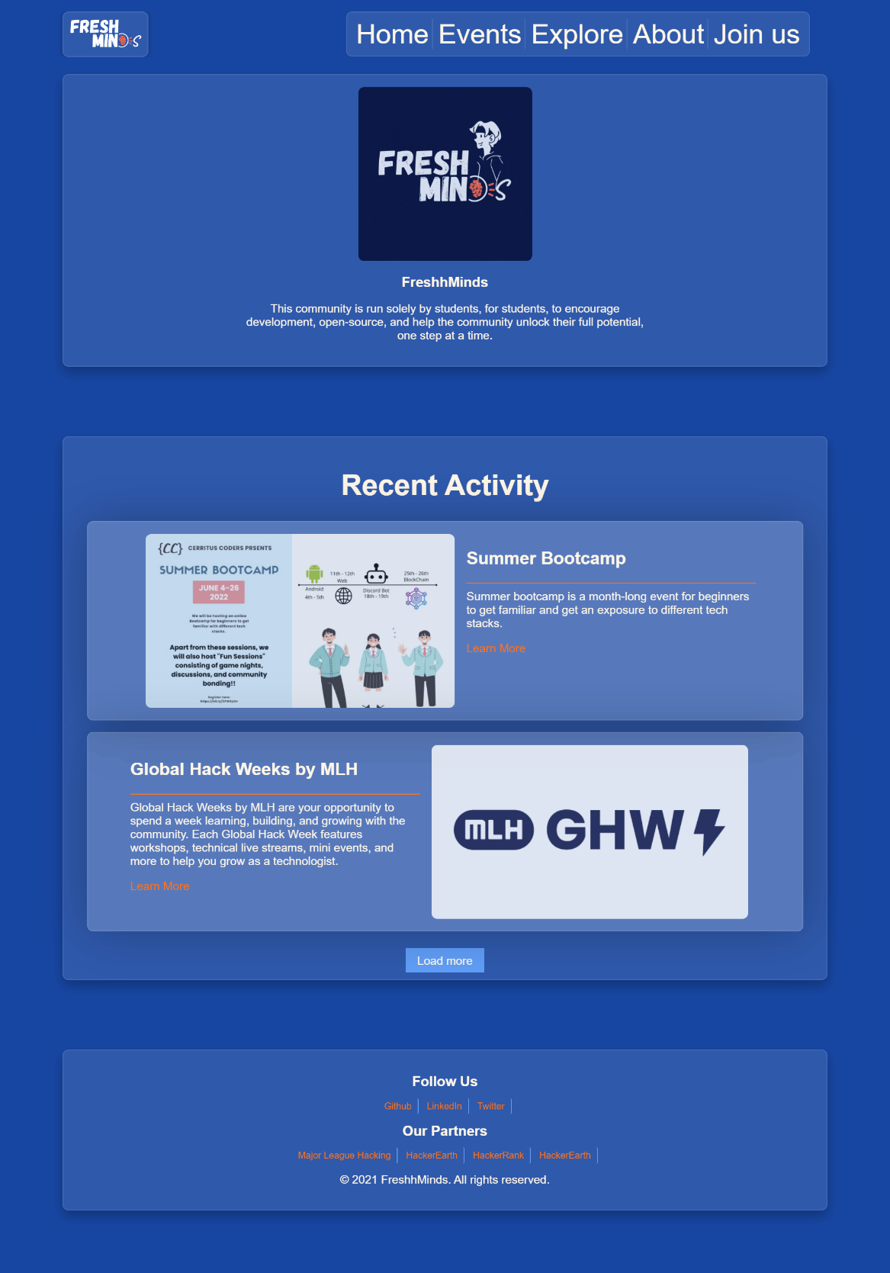

## events.html

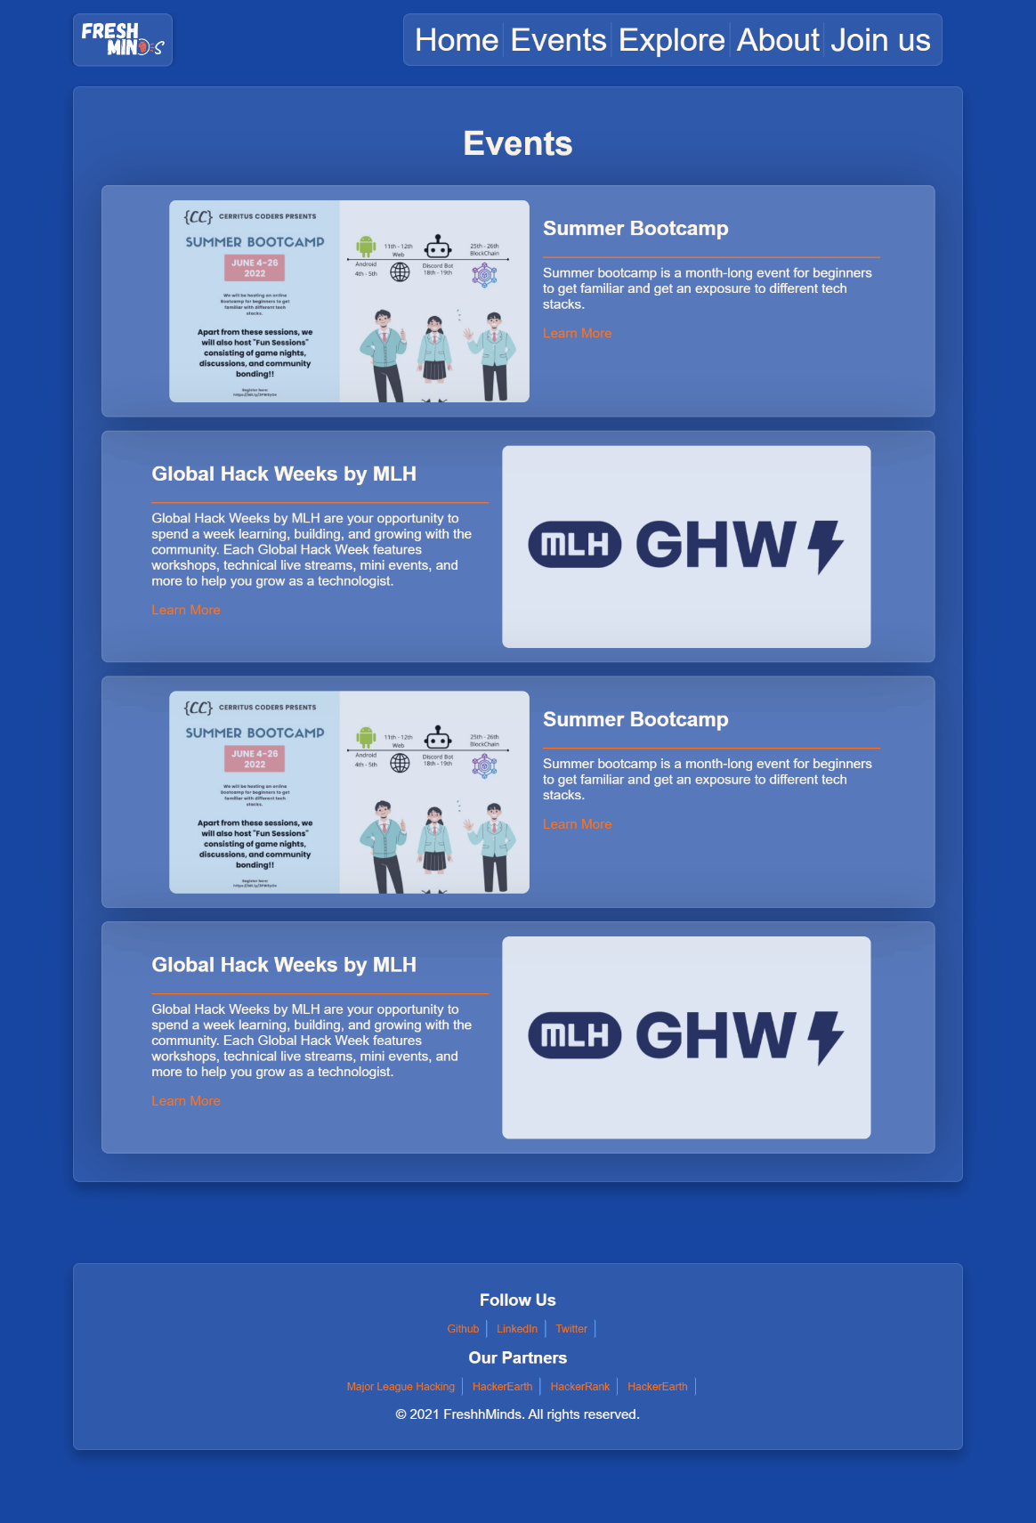

## explore.html

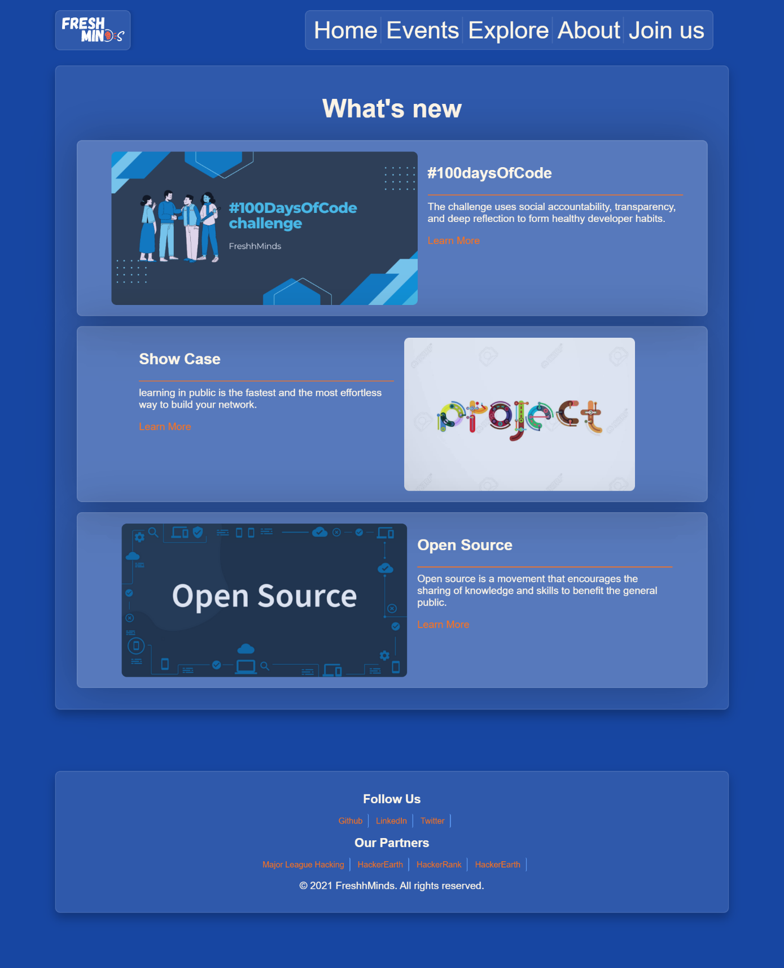

## about.html

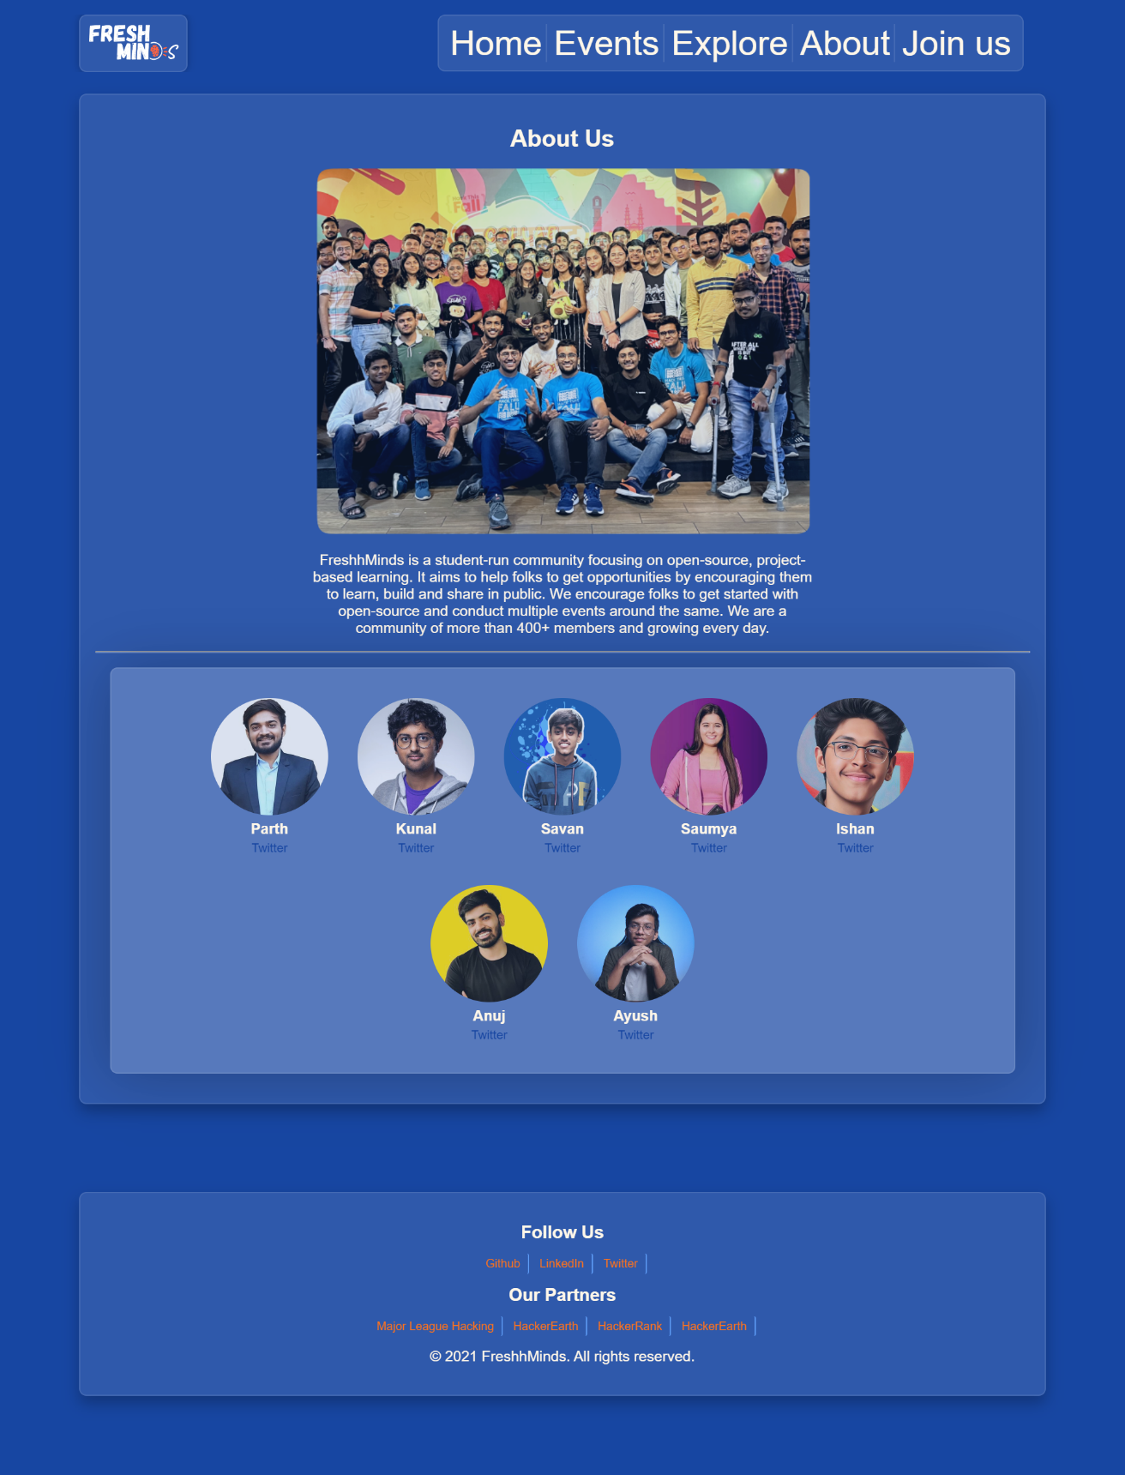

## ghw.html (Event)

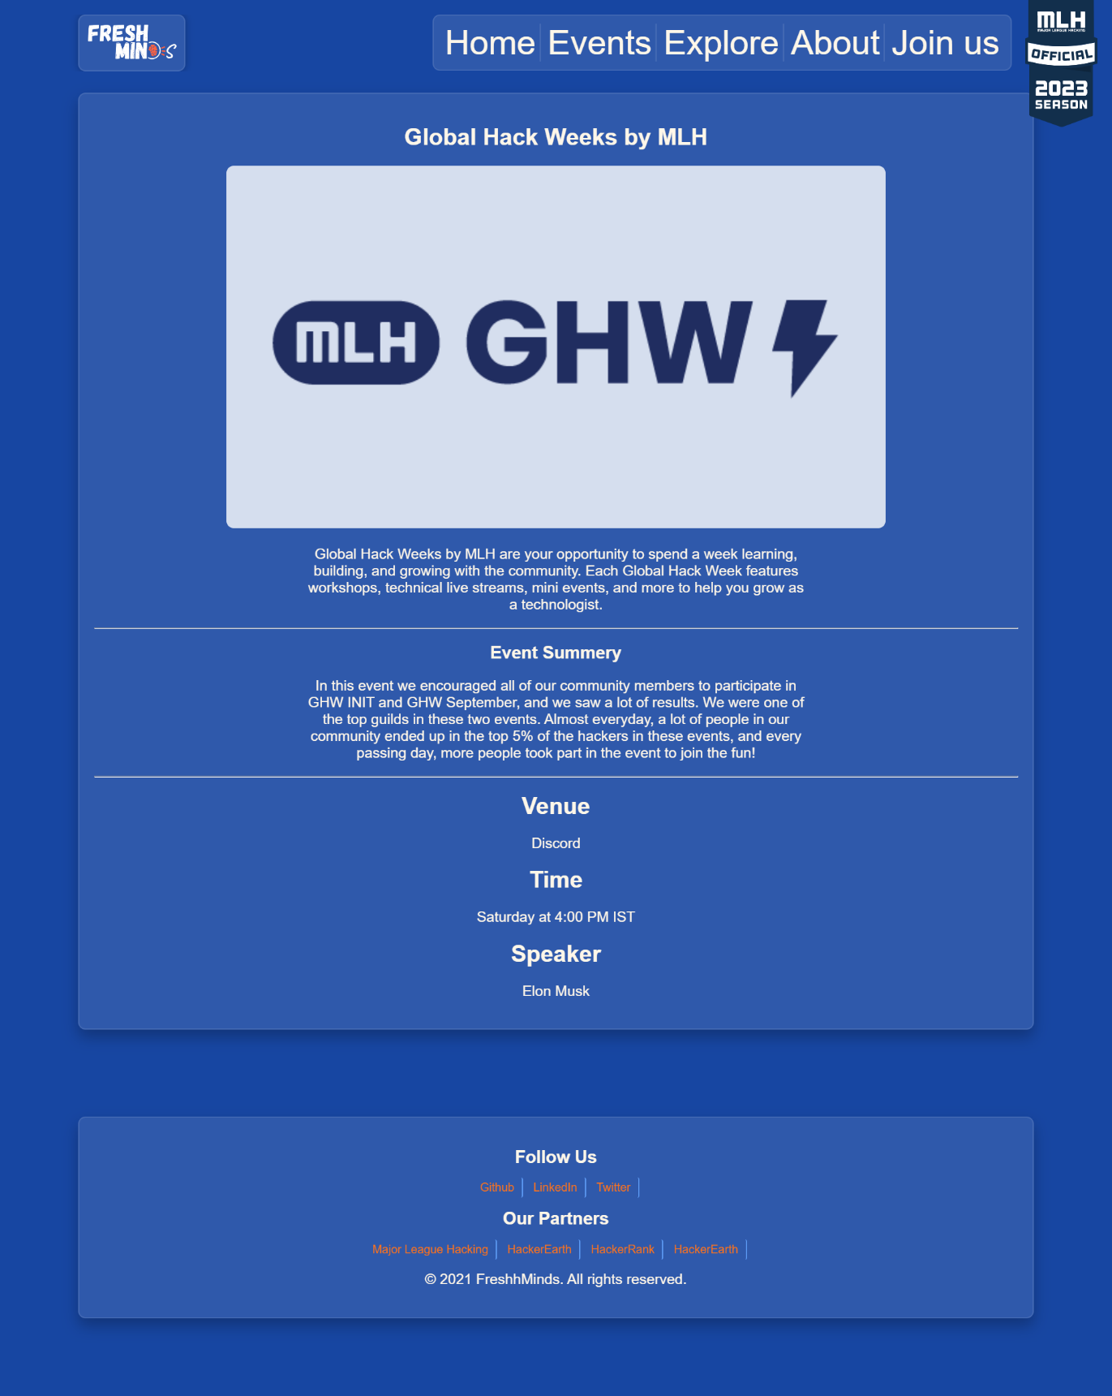

## 100daysofcode.html

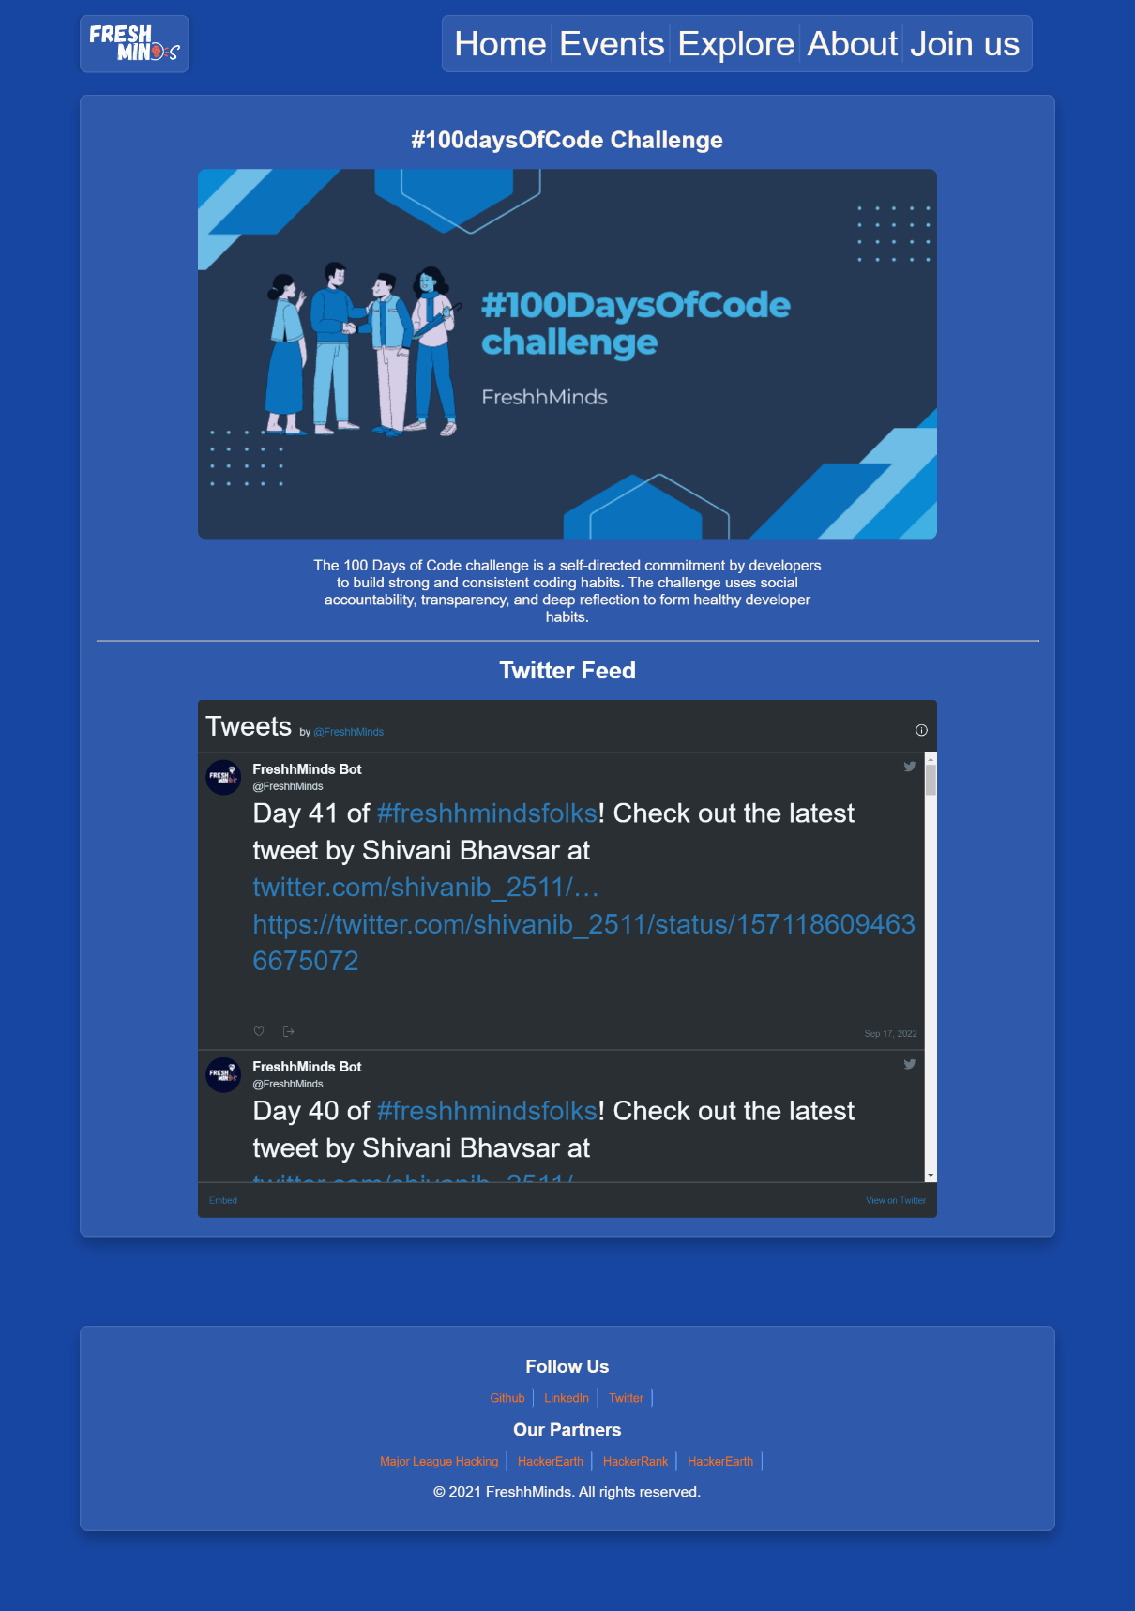

## showcase.html

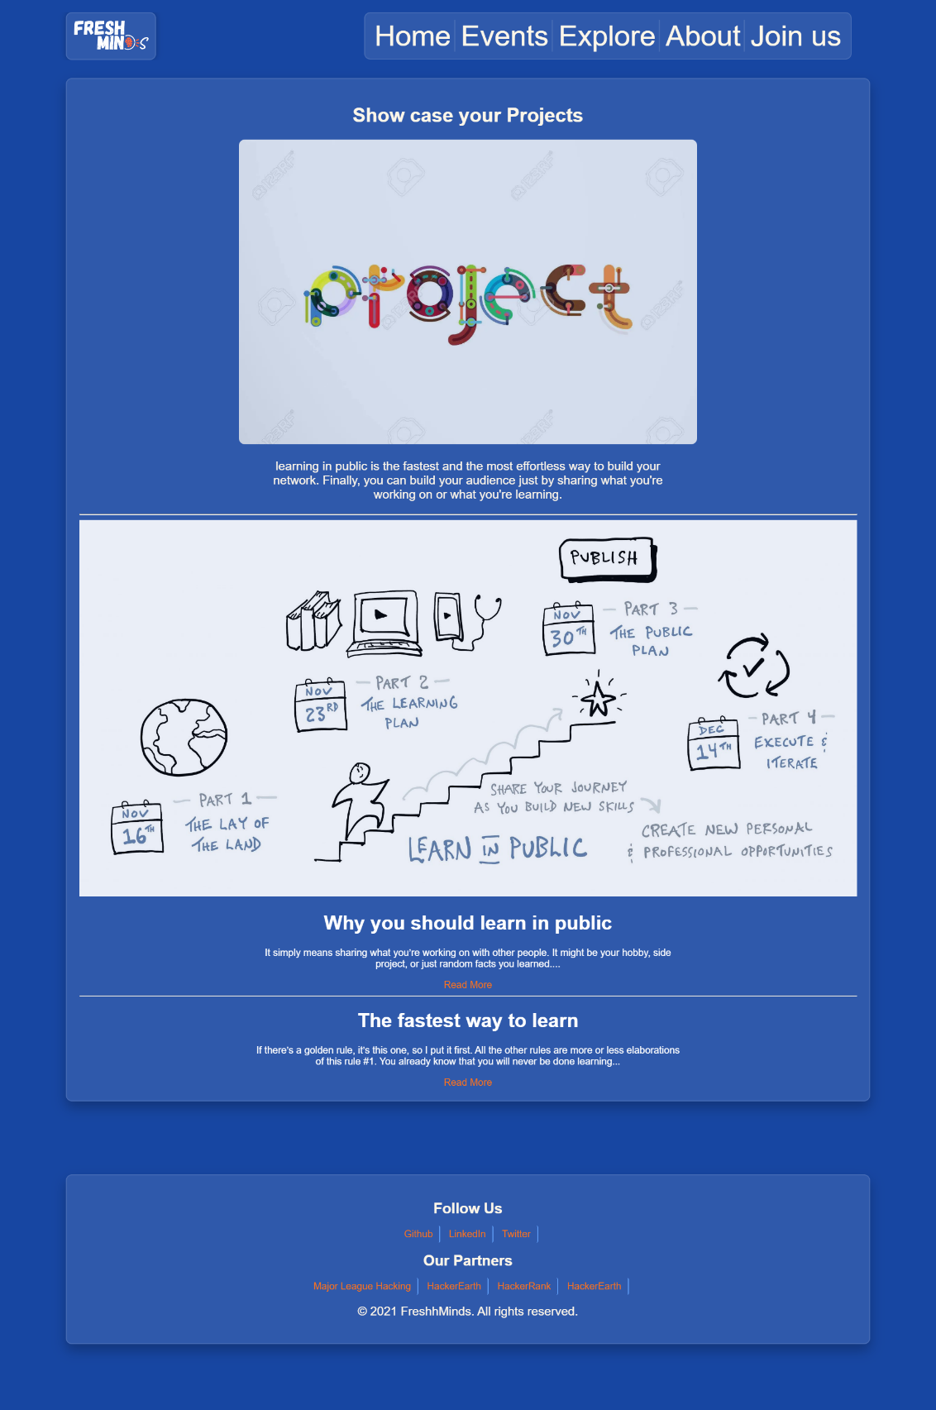

## opensource.html

